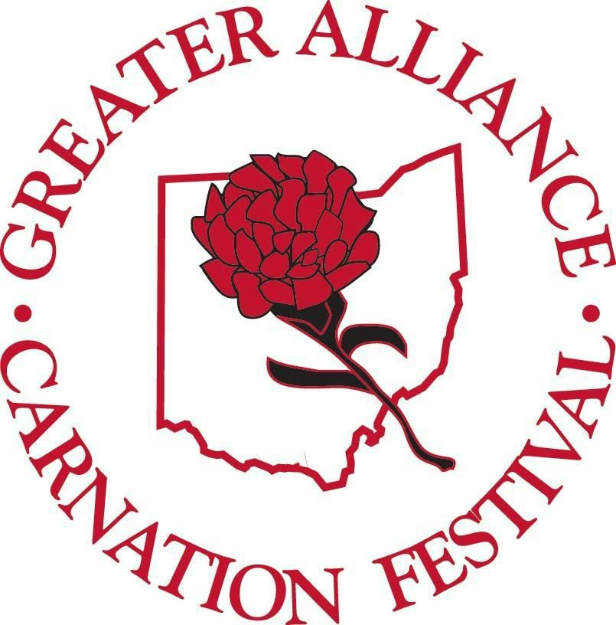 SHOWCASE YOUR CARNATION PRIDE!

2021 GREATER ALLIANCE CARNATION FESTIVAL
7th ANNUAL DISPLAY CONTEST GUIDELINES

*Businesses register at the Alliance Chamber of Commerce office -210 E. Main Street.

*Contest kit given, if needed, to first time business entries. (Kit consists of medallion & history of Scarlet Carnation
information card).

*Displays should be set up somewhere within your business & include at least 2 dozen fresh or artificial scarlet
carnations , and incorporate the 2021 pageant theme: "THE ROAD TO ROYALTY!"

* Displays need to be completed and ready for judging by Saturday July 17th and stay up until the end of festival
Sunday August 15th.

*Pictures of displays should be taken by JPEG and submitted to: Carnationfestival2019@yahoo.com
NO LATER THAN Monday July 19th. Pictures will be included on the Greater Alliance Carnation Festival
FACEBOOK page and voting for FAN FAVORITE will be done there until 5pm Friday August 6th.

* You are encouraged to invite your friends, customers and family to vote for you on the festival FACEBOOK website.

* Blind judging will begin Monday July 19th until Friday August 6th.

*Displays will be judged on ingenuity, originality, creativity, theme usage and overall use of carnations.

* Award categories will be based on Large & Small Business entries, Fan Favorite votes & the blind judging scores.

*Winning displays will be announced at Days in the Park on Wednesday August 11th on the website & on the
festival FACEBOOK page.

*Winner will be ceremonial starter for Carnation Festival Grand Parade, be eligible to ride in the Grand
parade, receive a plaque & city bragging rights.

*FACEBOOK Fan Favorite winner will receive a plaque.
Any questions please call
Missy Miller, Display Contest Chairman
330-428-2465

