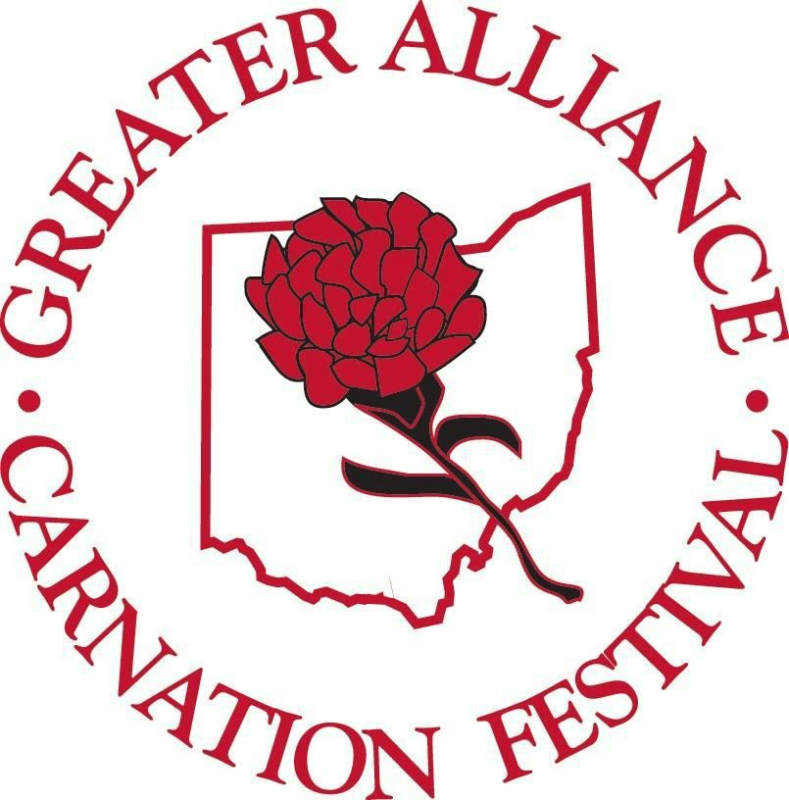 SHOWCASE YOUR CARNATION PRIDE!

2019 GREATER ALLIANCE CARNATION FESTIVAL
6th ANNUAL DISPLAY CONTEST GUIDELINES

*Businesses register at the Alliance Chamber of Commerce office -210 E. Main Street.

*Contest kit given, if needed. (Kit consists of medallion & history of Scarlet Carnation information card).

*Displays should be set up somewhere within your business, include at least 2 dozen fresh or artificial scarlet
carnations , and incorporate the festival contest 60th display theme: "A DIAMOND STUDDED JUBILEE!"
* Displays need to be completed and ready for judging by Monday July 22nd and stay up until the end of festival
Sunday August 11th.

*Pictures of displays should be taken by JPEG and submitted to: bbondoni@yahoo.com
NO LATER THAN Monday July 22nd. Pictures will be included on the Greater Alliance Carnation Festival
FACEBOOK page and voting for FAN FAVORITE will be done there until 5pm August 6th.

* You are encouraged to invite your friends, customers and family to vote for you on the festival FACEBOOK website.

* Blind judging will begin Tuesday July 23rd until Friday August 2nd.

*Displays will be judged on ingenuity, originality, creativity, theme usage and overall use of carnations.

* Award categories will be based on Large & Small Business entries, Fan Favorite votes & the blind judging.

*Winning displays will be announced at Days in the Park on Wednesday August 7th , on the web site & on the
festival FACEBOOK page.

*Winner will be ceremonial starter for Carnation Festival Grand Parade, be eligible to ride in the Grand
parade, receive a plaque & city bragging rights.

*FACEBOOK Fan Favorite winner will receive a plaque.
Any questions please call
Missy Miller, Display Contest Chairman
330-428-2465

