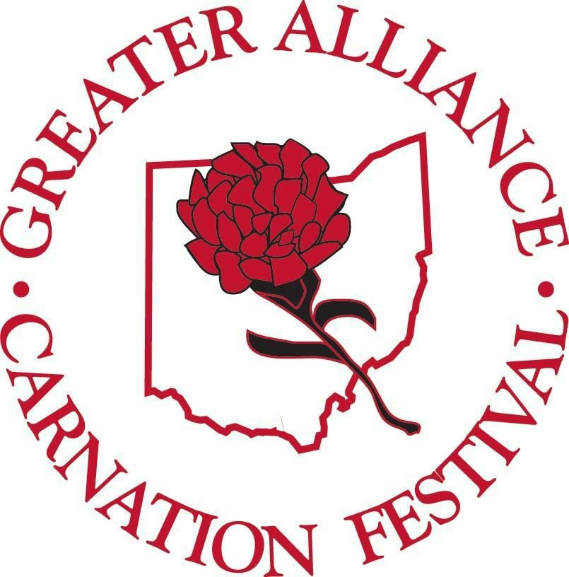
SHOWCASE YOUR CARNATION PRIDE!
2018 GREATER ALLIANCE CARNATION FESTIVAL
5th ANNUAL DISPLAY CONTEST GUIDELINES

*Area businesses register at the Alliance Chamber of Commerce office -210 E. Main Street.
Displays should be set up somewhere within your business.

*Displays should include at least 2 dozen fresh or artificial scarlet carnations. (Fresh carnations may be purchased by contacting Regina Clair at: 330-428-0129).

* Displays need to be completed and ready for judging by Tuesday July 24th and stay up until the end of festival Sunday August 12th.

*Submit your favorite display picture by JPEG to: inoj1983@yahoo.com
NO LATER THAN Tuesday JULY 24th. Pictures will be included on the Greater Alliance Carnation Festival FACEBOOK page where voting for FAN FAVORITE will be done there until 9pm SATURDAY AUGUST 4TH. You are encouraged to invite your family, friends & customers to vote for you .

*NO display pictures will be accepted after the July 24th deadline! (Multiple pictures will create a smaller collage of pictures limiting the size for viewing on the website).

* Blind judging will begin Wednesday July 25th until Friday August 3rd.

*Displays will be judged on ingenuity, originality and overall use of carnations.
Award categories will be based on Large & Small Business entries, Fan Favorite votes & the Blind judging.
Winning displays will be announced at Days in the Park on Wednesday August 8th, on the web site & on the festival FACEBOOK page.

*Winner will be the ceremonial starter for the Carnation Festival Grand Parade, be eligible to ride IN the parade, receive a plaque & city bragging rights. FACEBOOK FAN FAVORITE WINNER will receive plaque.

Any questions please contact:
Missy Miller, Display Contest Chairman...330-428-2465

